**Physical servers:**

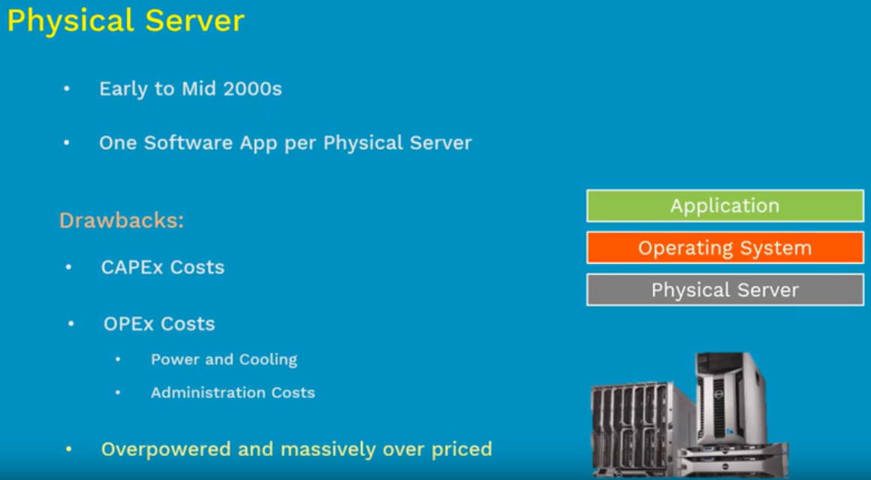

* Physical servers are too costly, and many resources remain useless in the physical servers’ earlier days
* It was used to run a single application on one physical server were not the lot of resource became useful and the costing was too much

**Virtual machines:**

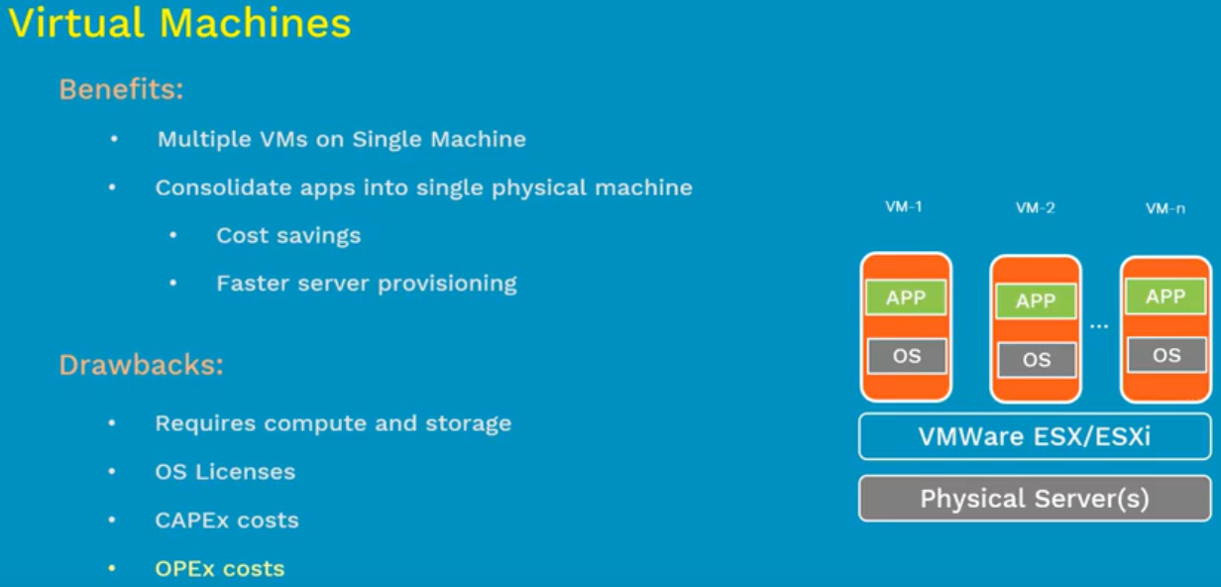

* VMware use to install multiple virtual machines on top of the physical servers and let to install multiple applications on a single physical server which helped to save the cost
* There are some drawbacks here like every virtual machine needed to install OS and it occupies the storage in all the virtual machines and not all the operating systems are free

**Containers:**

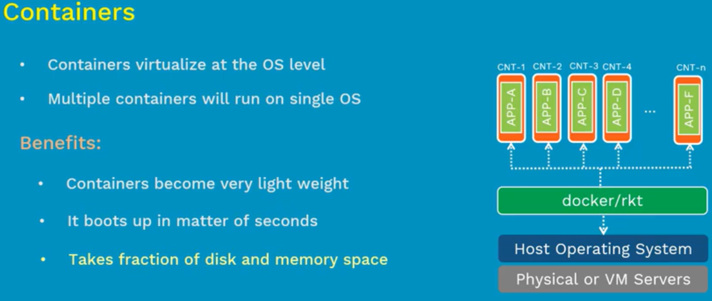

* Containers made this so easy. Docker or rocket are the container tools which runs on the top of host operating system

**VMs vs containers:**

